**Dataset link:**

[**https://data.gov.au/dataset/ds-act-https%3A%2F%2Fwww.data.act.gov.au%2Fapi%2Fviews%2Fc5h9-9bh7/details?q=diseases**](https://data.gov.au/dataset/ds-act-https%3A%2F%2Fwww.data.act.gov.au%2Fapi%2Fviews%2Fc5h9-9bh7/details?q=diseases)

# Visualisation 1: YLD Asr and Disease Group According to Gender

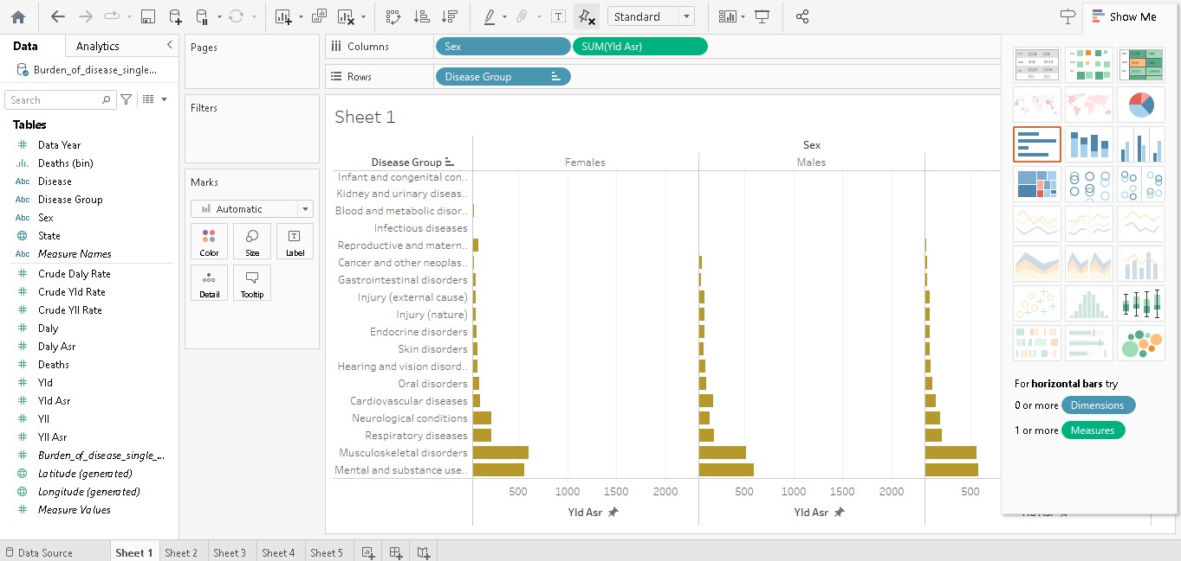

Figure 1: YLD Asr and Disease Group According to Gender

This graph shows the relationship between the YLD Asr and Disease Group According to Gender. According to the gender, the visualisation is done. Basically, it divided the complete graph into 3 factors, based on male, female and the other gender and the YLD rate is shown in each of the graphs according to the disease. According to visualisation, musculoskeletal disorders and mental and substance use diseases are more seen in all genders. This rate is high. Other disease like infant and congenital disease and kidney and urinary disease is seen at a minimal rate in all genders, so it means these are minimal among them. So basically, from these, the doctor has to focus more on musculoskeletal disorders and mental and substance use diseases and prevent the patient from it [1].

# Visualisation 2: Total Death According to the Gender.

This graph shows the relationship between the Total Death According to Gender. According to the gender, the visualisation is done. Basically, it divided the complete graph into 3 zones, based on male, female and the other gender, and the death percentage is shown in each of the graphs according to their disease. According to visualisation, the maximum death is seen in the person zone, which is around 4,95,329 people, and the male is the second hot zone, which is 2,69,125, and the last female has the lowest among them, which is 2,36,059. This death rate is high, So basically, from these, the doctor has to focus more on that patient so that they can prevent the patient from the diseases.

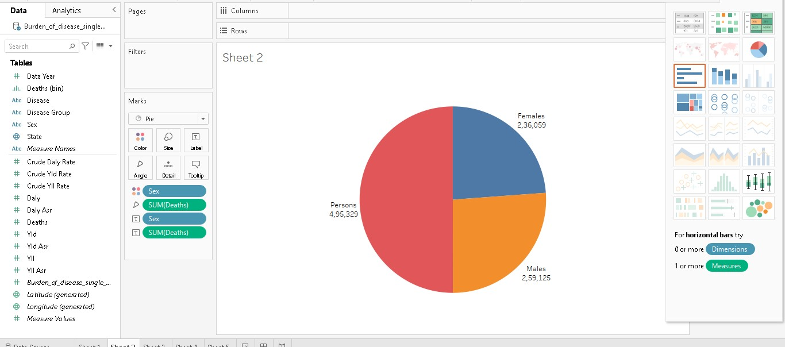

Figure 2: Total Death According to the Gender.

# Visualisation 3: Maximum Death in Years

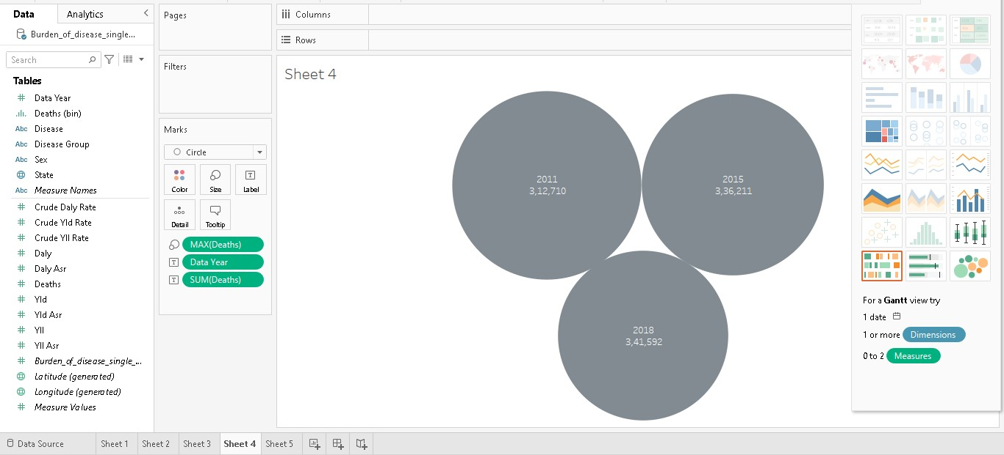

Figure 3: Maximum Death in Years

This graph shows the evaluation of the Maximum Death in Years. The graph basically tells in which year the maximum death occurred and in which year the maximum number of people died due to the diseases. The result shows the top 3 sets of years in which maximum death happened. According to visualisation, in the years 2011, 2015, and 2018, the maximum number of people who died which the numbers of 3,12,710, 3,36,211, and 3,41,592, respectively. The year 2018 has the highest rate of death. The second highest is 2015, and the third highest is 2011. So it is clear from the graph that recently the deaths have decreased, but in the previous year, the deaths were maximum [2].

# Visualisation 4: Sum of Daily Asr according to the Disease Group

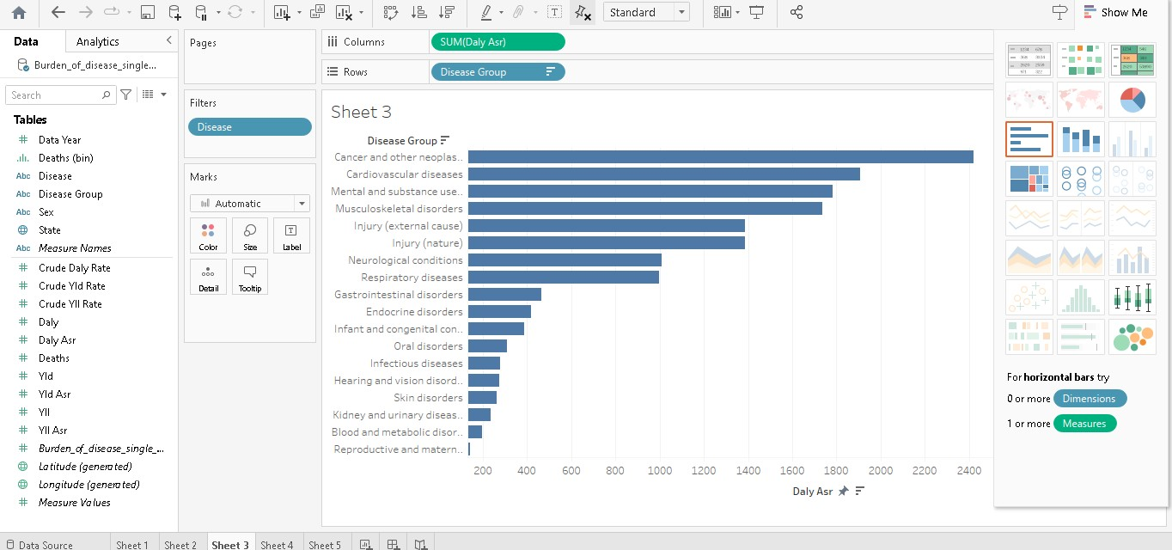

Figure 4: Sum of Daily Asr according to the Disease Group

This graph shows the relationship between the Sum of Daily Asr according to the Disease Group. According to the gender, the visualisation is done. The graph basically shows the total sum of the daily in each of the disease groups. According to visualisation, cancer, other neoplasms and cardiovascular disease are more seen in all people. This rate is high. Other diseases like blood and metabolic disorders disease and reproductive and maternal diseases are seen at a minimal rate in all peoples, so it means these are minimal among them. So basically, from these, the doctor has to focus more on cancer and other neoplasms and cardiovascular disease use diseases and prevent the patient from it.

# Visualisation 5: Total Deaths According to the Disease

This graph shows the relationship between the Total Deaths According to the Disease. The visualisation tells which diseases is most harmful for the patient or which disease has the highest death rate means human recovery chance is very minimal in which disease. And in other words, it helps to find which disease recovery chance is best. According to visualisation, coronary heart disease and dementia disease are more seen in all people. The death rate is high in these diseases. Other diseases like blood cancer, suicide disease and reproductive and maternal diseases are seen at a minimal rate in all people, so it means that these diseases are less effective than all other diseases that can cause death. So basically, from these, the doctor has to focus more on heart disease and dementia disease use diseases and prevent the patient from it [3].

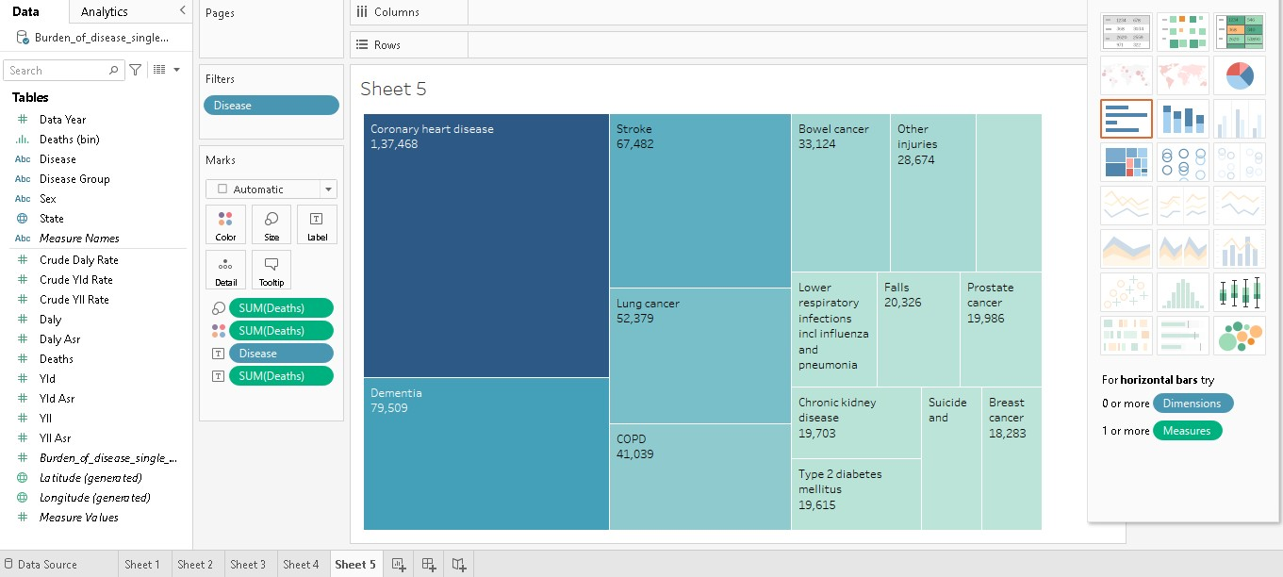

Figure 5: Total Deaths According to the Disease